## Final Project FA5

1. Extract the **“gupta-ambuj-fa5.zip”,** and run only **“gupta-ambuj-fa5.sh”.**All the necessary files are uploaded to one remote file server. Those will be downloaded by the shell file.
2. Run the shell file using below command.

bash gupta-ambuj-ma5.sh ELB-AMBUJ1 ambujkey DAVINCI455 2 ambuj-gupta-1 ambujrole

1. In this script RDA database and read replica are created. MYSQL DB Name is **“FA5CLOUDDB”** and Read Replica name is **“ReadFACLOUDDB”.**
2. SQS name is **“FA5QUEUE”** and SNS topic **“ImageDone”** and email subscription has been made to “agupta61@hawk.iit.edu”
3. The above script will take 20-22 minutes for execution.
4. Now go to the worker instance, it will be one which is not attached to Load Balancer. Same can be found from AWS console.
5. Both .Jpeg and .png images can be uploaded and compressed.
6. For Table creation run “DbCreate.php” at worker instance. This script will create table in Database with name “USER_INFO”.

<http://54.174.108.45/DbCreate.php.php>

1. For Testing Index page , request index.php page at loadbalancer url.

<http://elb-ambuj1-1596358799.us-east-1.elb.amazonaws.com/index.php>

1. Now Request “workerinfinite.php” at worker instance. Since it is an infinite loop and it will starts when it gets executed for 100000 times, We see browser loading. Then again it can be started by calling the workerinfinite.php

<http://54.174.108.45/workerinfinite.php>

1. Once the User subscribe for the SNS topic, it can see notifications in email.
2. It the User is uploading the image for the first time , it will receive subscription email.
3. After the user gets the notification of **“Congratulations image processed.!”** It can see the images by giving email id at index.php page.

## Screen-shots

1. Running the Script:

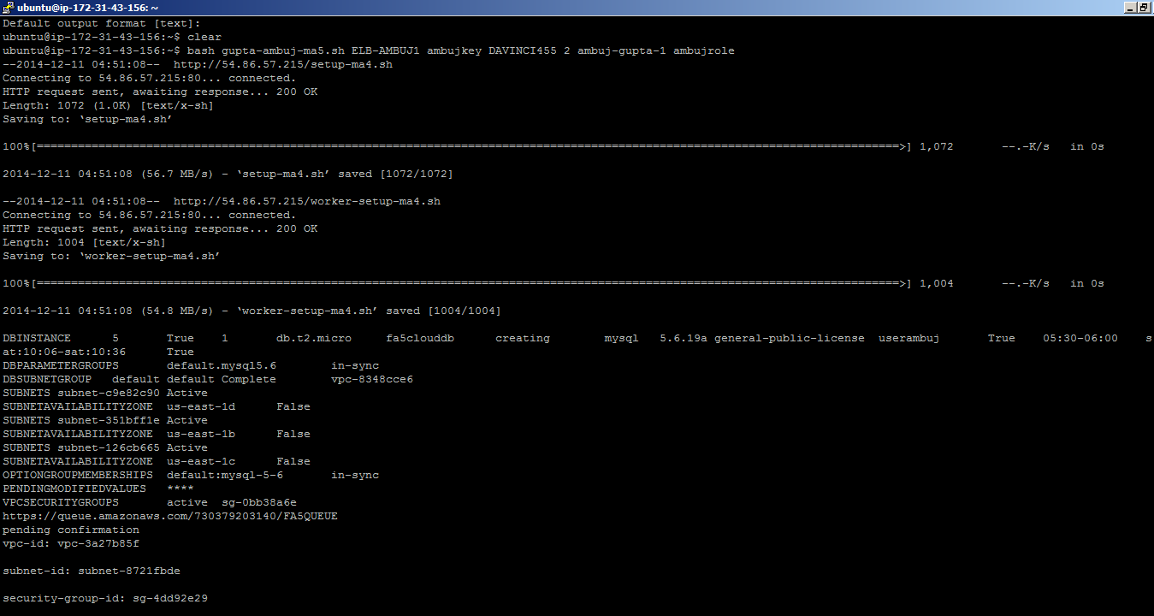

1. Index page.

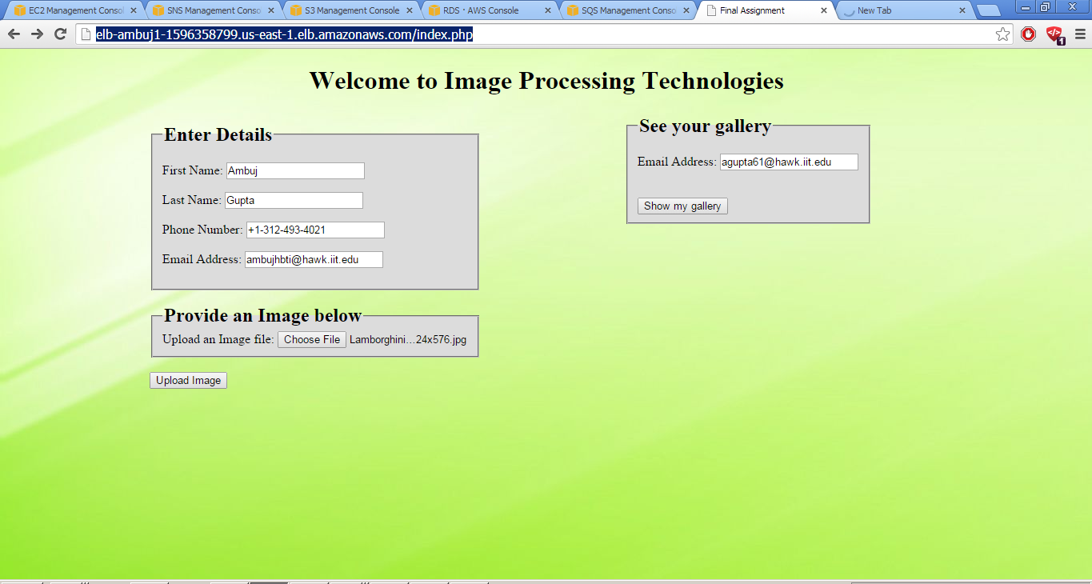

1. Image has been uploaded to S3 Bucket

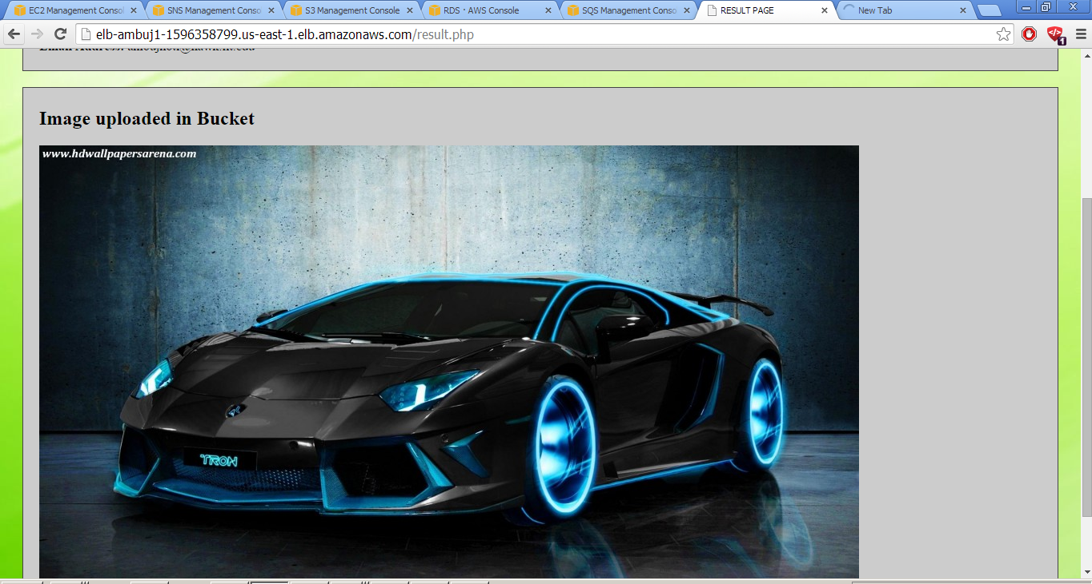

1. Worker instance in action. It never loads due to while loop in php code.It

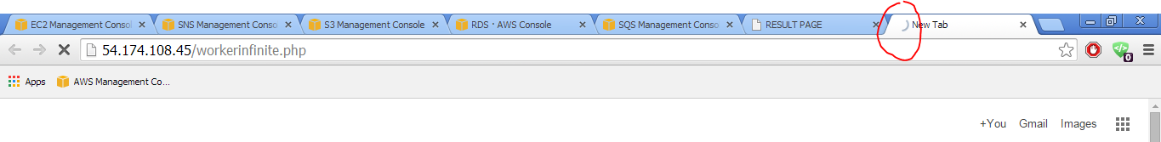

1. SQS Queue

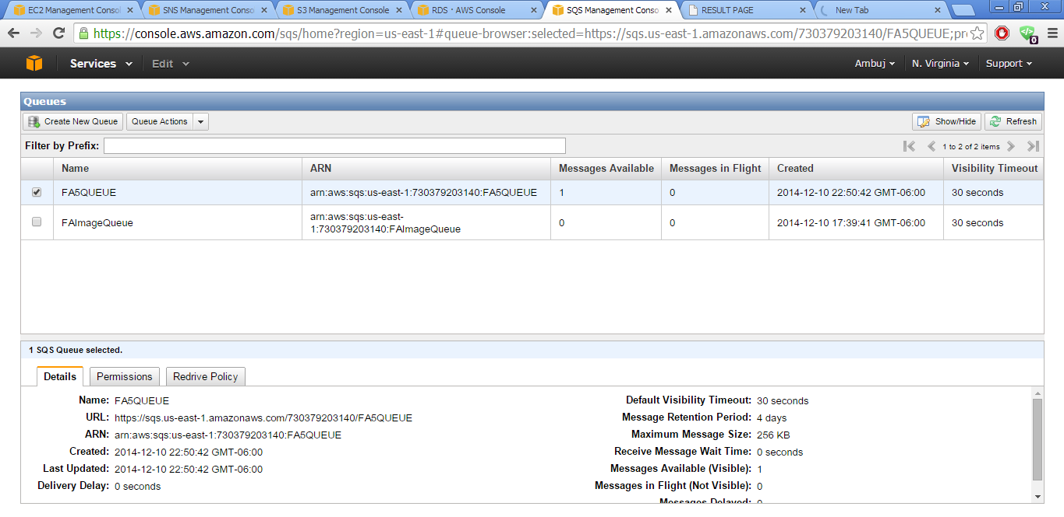

1. Email notifications

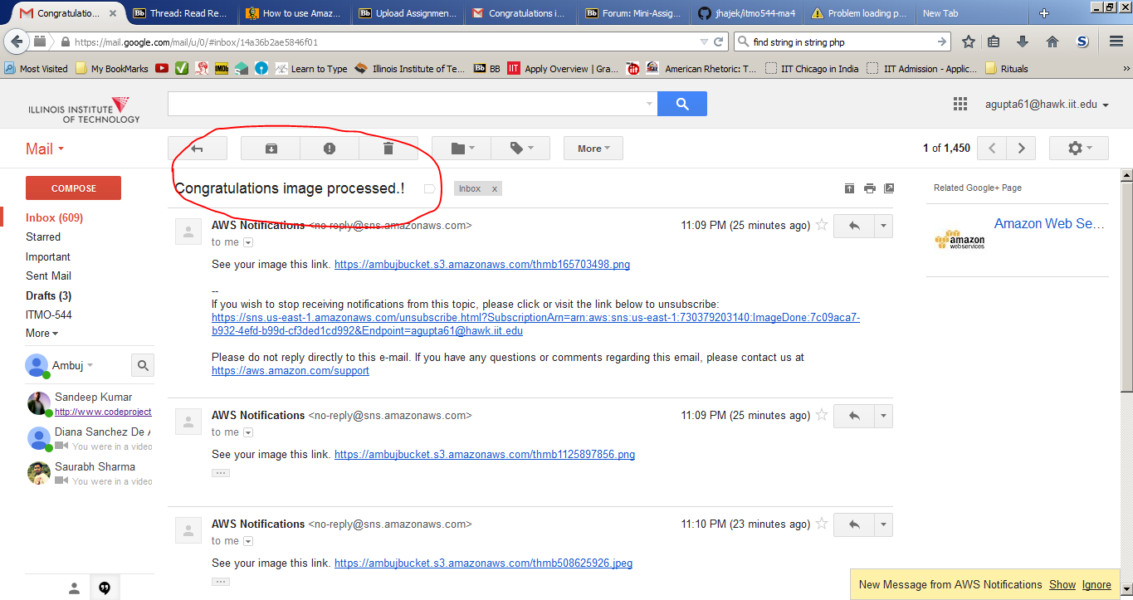

1. Provide the email id and click “Show My Gallery”

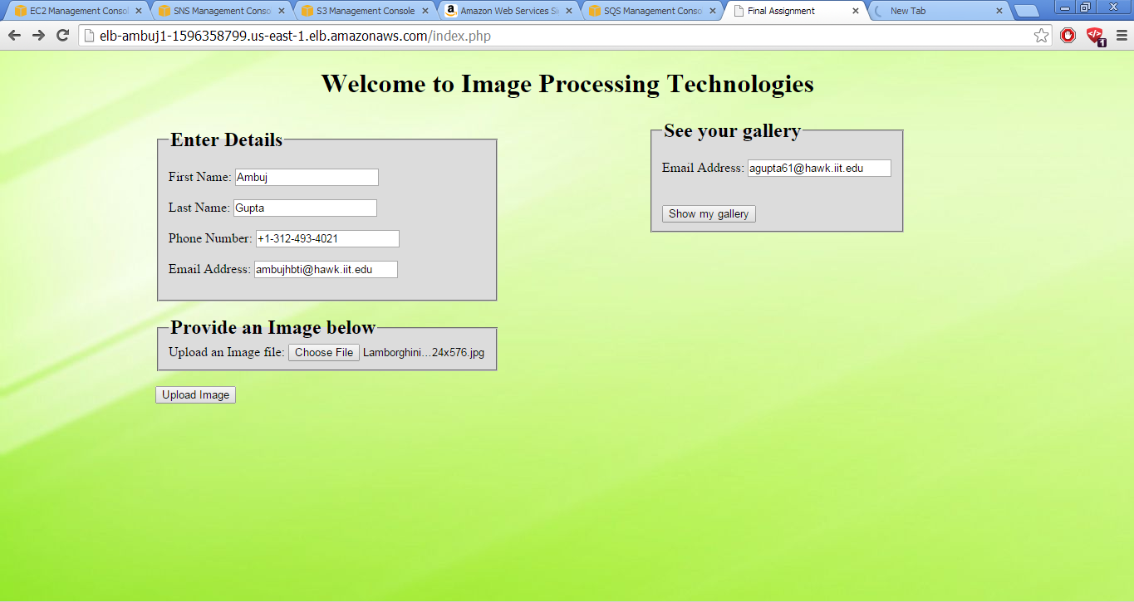

1. Gallery.php page

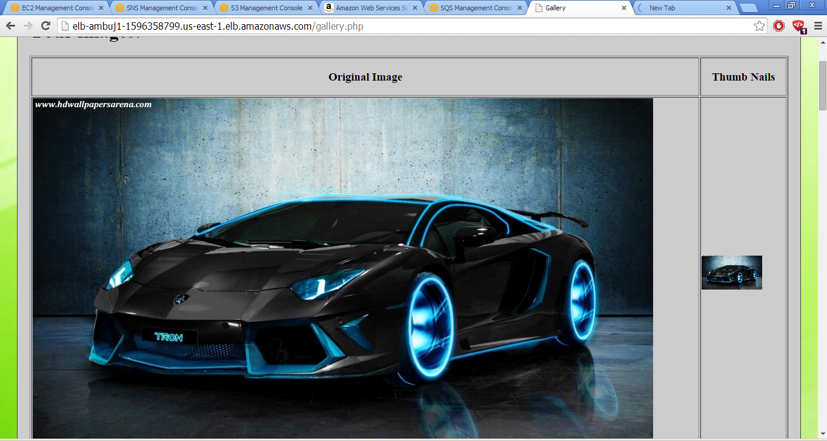

Thank you.